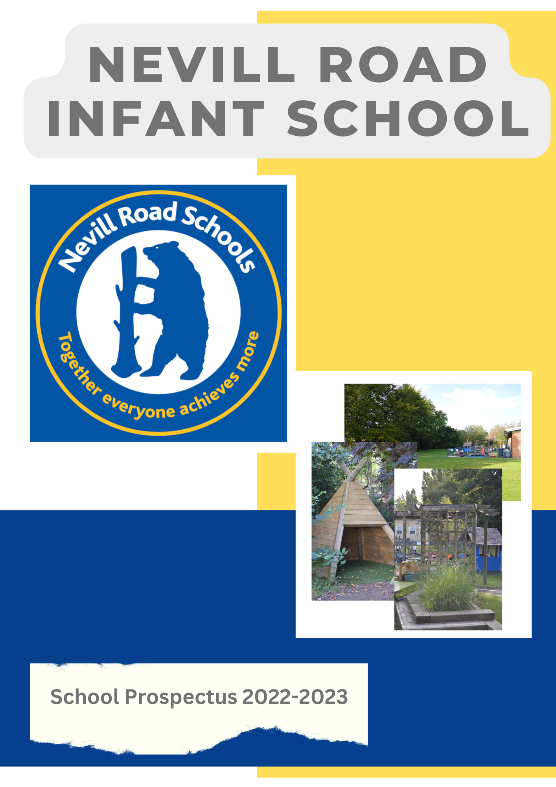
A message from the Headteacher
I am delighted to introduce our school prospectus and hope that you will enjoy finding out about Nevill Road Infant School. As you will see from the photographs and information in this booklet, this is a very happy, caring, inclusive and vibrant school, where learning is fun and everyone strives to do their best. I am honoured to lead such a popular and thriving school that aims for excellence in all areas and look forward to the next step on our journey.

Children are always at the heart of everything we do at Nevill Road Infant School and they enjoy a rich, diverse and stimulating curriculum, high quality teaching and excellent support for their individual needs. A wide range of extra-curricular activities, trips, events and special experiences help our pupils to enjoy their learning and motivate them to achieve to their full potential.

As well as achieving high standards in national assessments, our children make very good progress in all areas of the curriculum as they move through the school.

A positive feature of this school is the involvement of our parents and carers. This might be through membership of our successful Friends of Nevill Road Schools or by volunteering to help in class or on trips. Our parents are actively welcomed into the school to help with in-school activities, share their expertise, attend events and celebrate with us.

I hope that you enjoy reading our prospectus and find the information helpful. You can find out more about our school by looking at our website. If you wish to visit the school to see us at work for yourself, then please contact the school office and we will be happy to show you around.

Jonathan Whitfield B.Ed Hons NPQH

A message from the Chair of Governors

Welcome to Nevill Road Infant School. I am proud to be Chair of Governors here at our warm, vibrant school in which every single child is nurtured and empowered to achieve their full potential.

As Governors, we work closely with Mr Whitfield and his enthusiastic team of specialist early years and key stage 1 educators, all of whom are absolutely committed to delivering a dynamic, modern curriculum in a way which genuinely instils a love of learning.

Here at Nevill Road Infant School, your child will be part of a very special school community: as an infant school, we are fortunate to be able to really focus on the early stages of our children’s school journey; however, our close links with Nevill Road Junior School also enable our children to access all the benefits of a through school and to ensure a seamless transition when the time comes to move on to year 3.

We look forward to welcoming you and your child, and we know you will love this very special school as much as we do!

Caroline Wilke
Chair of Governors

Our Vision

At Nevill Road Infant School we are driven by the desire to provide the best possible education, opportunities and environment for all who are part of our school.

As an infant school we are passionate about children’s early development and devote our time to embedding a desire for lifelong learning.

We ensure that all children are given equal opportunities and equal access to every aspect of the curriculum, including all activities at school.

Our school is an inclusive and nurturing environment where all aim high, achieve well and develop self-confidence.

Resilience and a love of learning, including positive values and beliefs, cooperation and team work, a sense of community and caring attitudes towards others underpin all our work in school.

We provide an exciting, challenging and inspirational setting where children become independent, creative thinkers who are reflective and always striving to extend their learning.

We aim to be at the forefront of educational best practice and our children will benefit from our desire to give them access to the latest technological and educational developments.
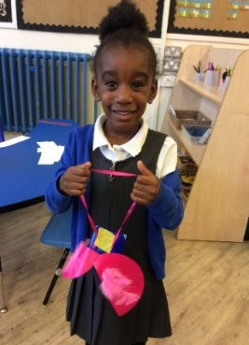

About Bramhall
Bramhall lies to the South of Stockport and has a lovely community village feel to it. There are parks, gardens, shops and restaurants in the bustling centre.
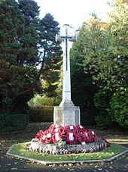
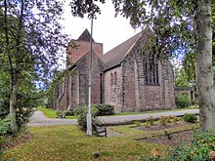

About Nevill Road Infant School

Nevill Road Infant School is a popular and well-respected 3-form entry school with provision for children from aged 2 to 7. The school site is safely contained with its own environmental garden, allotment, 2 playgrounds, a field and outdoor learning / play areas for Nursery and Reception aged children. The school shares a site with the Junior-school provision ensuring a smooth transition from infant to junior education.

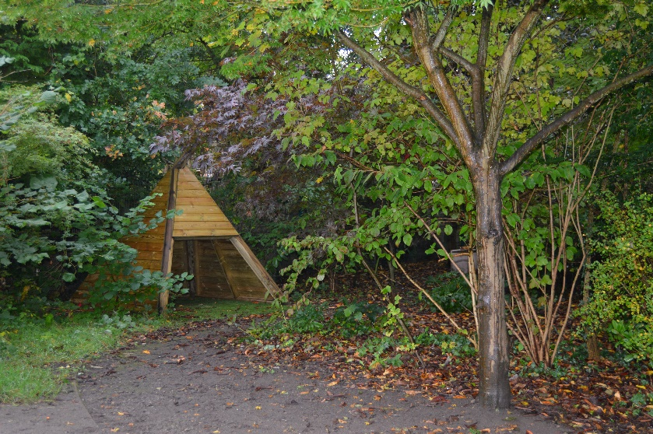

Our pupils

Everyone who visits us comments on two things; the wonderful atmosphere and the children they see in and around the school. The children are polite, respectful, responsible and enthusiastic and they flourish in a purposeful atmosphere of nurture, learning and enjoyment.
The children at Nevill Road Infant School are always at the absolute core of everything we do and their safety, wellbeing and happiness are of greatest importance to us.
All of our children are arranged into class groups named after endangered animals:
Little Brown Bears Pre-school Age 2-3
Elephants Nursery Age 3-4
Giant Pandas / Koala Bears / Polar Bears Reception Age 4-5
Sea Otters / Blue Whales / Sea Turtles Year 1 Age 5-6
Lions / Tigers / Leopards Year 2 Age 6-7

Our Values

As well as upholding British Values we also aim to help our children grow in to well-rounded citizens through instilling core values within them.
Nurture – We want all of our children to feel safe, cared for and provided with the opportunities in which to flourish – nurturing all of them to be the best they can is very important to us
Enjoyment – We want all of our children and staff to find enjoyment in each day; whether this is in learning, in play or in everyday experiences
Voice – We think it is important that our children grow and develop a voice; a sense of opinion, individuality and the sense to have a say in their ongoing learning
Independence – Our children should be developing into individuals who are self-reliant, able to do things for themselves, self-aware and able to know their strengths so they can be built upon
Love of Learning – Our aim here is that the children are provided in the right opportunities to be motivated, excited and eager to both learn ‘in the moment’ and equipped to further educate themselves in the future
Resilience – Never giving up is something we see as an essential mindset to develop within the children, having the resolve to see things through, to keep learning and to be creative problem solvers
Discovery – We want our children to find excitement in school and learning and we aim to be a place of discovery for them through new learning, self-awareness and instilling a sense of being goals-driven

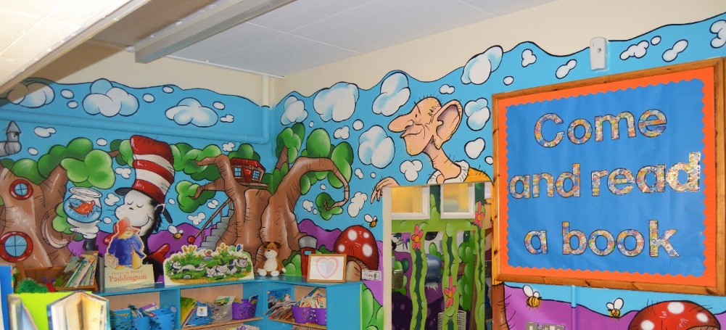

Our Staff
Senior Staff:
Mr Jonathan Whitfield Headteacher
Mrs Emma Stoddart Deputy Headteacher / Early Years Leader
Mrs Charlie Scott SEN & Inclusion Co-ordinator
Miss Ruth Lea Y2 Teacher
Mrs Nicola Fallon Y1 Teacher

Teaching Staff:
Miss Ellie Pickles Y2 Teacher
Miss Charlotte Taylor Y2 Teacher
Mrs Jen Hamey / Mrs Kate Whiteley Y1 Teacher
Miss Caitlin Parvaz YR Teacher
Miss Beth Ahmed YR Teacher
Miss Orla Wilson YR Teacher
Miss Izzy Ivy Nursery Teacher
Mrs Lauren Spensley Little Brown Bears HLTA
Mrs Dawn Whitehead Little Brown Bears HLTA
Mrs Maggie Pycroft PPA / Intervention Teacher
Mrs Suzy Easdown PPA / Intervention Teacher

Admin Staff:
Mrs Sharon Kyne School Business Manager
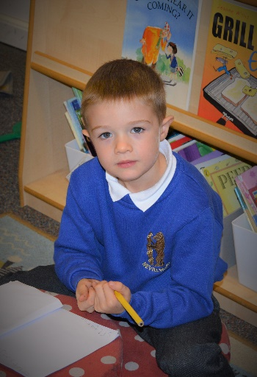
Miss Carole Agnew School Receptionist
Mr Norman Caretaker

Teaching Support Staff:
Mrs Samira Azimi Teaching Assistant
Mrs Amanda Barker Learning Mentor
Miss Alison Dowell Nursery HLTA
Mrs Kerrie Fisher Teaching Assistant
Mrs Delyth Fitchett Teaching Assistant
Mrs Debbie France After School Club Play Assistant
Mrs Hazel Gannon Teaching Assistant
Mrs Emma Geary Teaching Assistant
Mrs Mandy Gray Teaching Assistant
Mrs Karen Hadfield After School Club Play Assistant
Miss Lisey Hadfield After School Club Play Assistant
Mrs Tracy Harrison Teaching Assistant
Ms Rachel Hartley-Dickens After School Club Manager
Mrs Vicki Hopkinson Teaching Assistant
Mrs Aziza Kennaoui Midday Supervisor
Mrs Joanne Leach After School Club Play Assistant
Mrs Shirley McCabe Teaching Assistant
Mrs Clare Milner Teaching Assistant
Mrs Jackie Moran Teaching Assistant / Play Assistant
Miss Ashleigh O’Brien Teaching Assistant
Miss Amy O’Grady Teaching Assistant
Mrs Shelley Paulls Teaching Assistant
Mrs Karen Quinn Teaching Assistant
Mrs Kerry Ruane Teaching Assistant
Mrs Hamdam Shaeiri After School Club Play Assistant
Mrs Sam Simpson Teaching Assistant
Mr Tom Sherwood Sports Coach
Mrs Lynsey Sturgess Midday Supervisor
Mrs Janine Taylor Teaching Assistant
Miss Hayleigh Taylor Teaching Assistant

Our curriculum

At Nevill Road Infant School learning is fun and all of our children are supported and challenged to enjoy learning and reach their potential. Learning in the outside environments, practical and real-life situations and special activities all help to make learning accessible and help to motivate our pupils to achieve well and become lifelong learners. We have a very positive approach to learning at our school and children are encouraged and rewarded when they do their best, work hard and make good progress.
Our curriculum is based on the statutory National Curriculum; it is skills based in design and intended to provide learning and teaching motivation for both children and teachers.
We aim to be as creative as possible with our approach to the curriculum, teaching and learning; there are 6 distinct topic elements inclusive of a stunning start, a marvellous middle and a fantastic finish.
Every year group includes high quality book and text studies within their termly topic plans, making sure children are given a text-immersive experience.
All of our topics are supported through high quality resources, trips, visitors and experiences that provide ample opportunity for real depth of study.

 | Autumn | Spring | Summer
Little Brown Bears | This is Me! | Spring into Spring | Book Worms
 | Celebrate! | Nature, nature everywhere | Let’s pretend!
Elephants | There’s only 1 me! | What will I be? | How does your garden grow?
 | Let there be light! | It’s just right! | The places I’ll go
Reception | Marvellous Me! | Explorers Unite! | Turrets & Tiaras
 | Twinkle, Flicker & Bang! | Old MacDonald | A long, long time ago…
Year 1 | Mirror, mirror on the wall | Back to the Future | Precious Planet
 | Starry, starry night | Great Manchester | Carnival of the Animals
Year 2 | Globetrotting | Fantastic Females | Amazing Artists & Brilliant Builders
 | Into the Forest | Our Secret Garden | Local Life
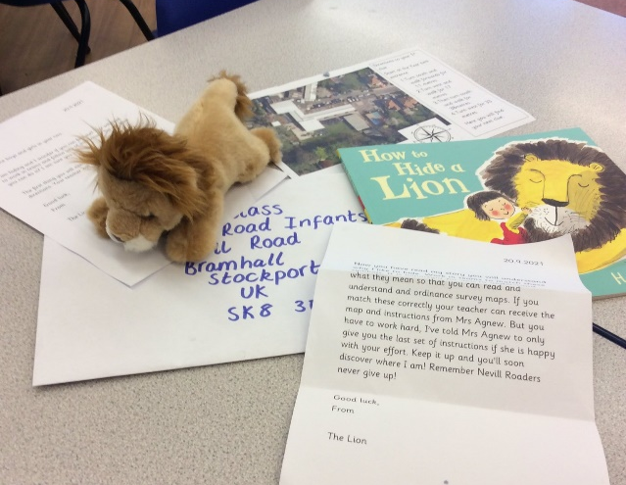
Home Learning
Home learning is an important part of school life at Nevill Road Infant School and we value the impact it can have. We are also realistic that it should not take over nor take the place of real teaching but should be a shared experience.

At Nevill Road, our home learning is concerned with providing parents and carers with the opportunity to take part in helping with the basic skills of reading, phonics, spelling and counting.

We know that home learning is most effective when it involves the child talking about their school work with parents and carers and we encourage all of our parents, carers and children to do so.

Extended Services – breakfast club, after school club, extra-curricular

We are very fortunate to be able to offer wrap-around extra-curricular provision in the shape of before school breakfast club, after school club and extra-curricular opportunities.

Our breakfast club provision runs from 7:30 to 8:45 and is available for all children every school day. Current costs for breakfast club are £6.

Our after school club provision runs from 3:15 to 6:00 and is available for all children every school day. Current costs for breakfast club are £5 (to 4:15pm) £6.50 (to 5pm) £8.50 (to 6pm).

At certain times throughout the year we may also offer additional clubs that are usually run by teaching staff; these will attract a nominal charge.

Collective Worship

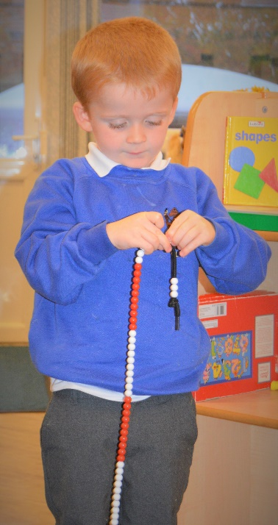
Collective worship is an important element of our school day; it helps us to focus on the important things in life and take a moment of reflection. There is a daily act of collective worship through a variety of whole school assembly, year/class assembly, philosophy and circle time.
Parents have the right to withdraw their children from collective worship and Religious Education without discrimination, please speak with Mr Whitfield if you would like this to happen.

Home – School Links
There are many ways we aim to keep you informed about your child’s learning and progress and encourage you to be fully involved in the life of the school. Newsletters are sent out on a weekly basis celebrating achievements, informing you of special events and trips and noting any changes to routines.
At the beginning of each year a starter pack is sent home that includes details of all the important information for your year group. It is an essential reminder of how we work and a chance for parents and carers to begin to get involved.
Topic Tasters are sent home at the beginning of each term or half term to give parents an overview of the curriculum to be covered by their children during that term and any special events or trips that are coming up.
Each term parents are invited to meet formally or informally with their child’s teacher at our parent teacher meetings to discuss their child’s progress and targets for the next stage of their learning. We also run weekly reading mornings when our parents are welcomed into their children’s classes from 8:30 each Friday to read with their child in their classrooms until the bell goes. Parents must stay with their child until start of school.
Reports are sent home at the end of the summer term for all children providing a detailed profile of what your child has achieved, the progress that they have made and targets for further progress. Early Learning Goal Achievement in Reception, Yr.1 & 2 Phonics Screening, Yr. 2 Teacher Assessments / National test results are included in the annual report. We additionally send home report update cards indicating how much progress your child is making and what they are working towards.
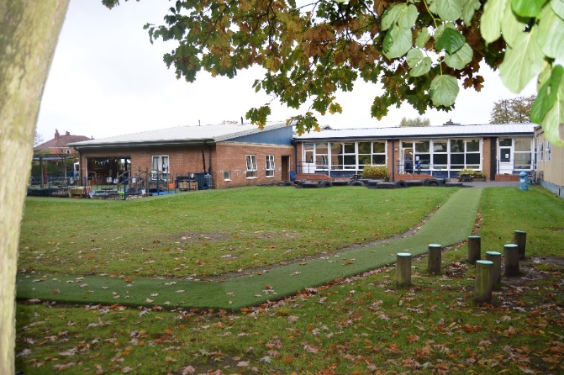
We operate a paperless policy wherever possible and have a very successful messaging and email service to ensure all parents and carers are regularly kept up to date.
School policies are available for parents to look at from the main school office or on our website.

Community Links

We aim to be at the centre of the community we serve and reflect the cultures and beliefs there. Alongside this, we strive to work with local partners, businesses and organisations to make school and community life richer. We support and regularly raise money for:

Sport Relief Comic Relief Macmillan Cancer NSPCC

Each of our school houses also has a charity they raise money for:

Bruntwood Mrs Scott Chelwood Food Bank
Lyme Miss Lea Winston’s Wish
Vernon Miss Parvaz Children in Need
Woodbank Mrs Fallon World Wildlife Fund

Disability and Equal Opportunities

At Nevill Road Infant School we seek to foster a warm, welcoming and respectful culture, which allows us all to question and challenge discrimination and inequality, resolve conflicts peacefully, promote equality and work and learn in a safe environment.
We recognise that there are similarities and differences between individuals and groups but we will strive to ensure that our differences do not become barriers to participation, access and learning and create inclusive processes and practices, where the varying needs of individuals and groups are identified and met. We therefore cannot achieve equality for all by treating everyone the same. We believe we all have equal rights, but may have different needs.
This is achieved by ensuring the well-being of all pupils. Our well-being outcomes are embraced in every aspect of school life: personalised teaching and learning approaches; access to ICT; assessment for learning which engages pupils in having a say about their progress and SEND provision; and partnership with parent/carers, other schools and the local community.

Attendance and Punctuality

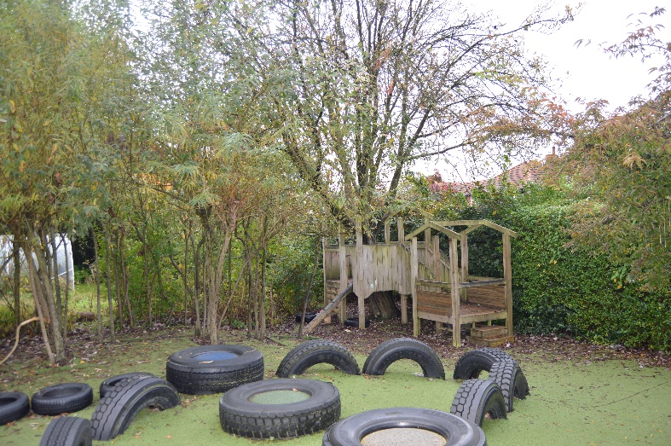
We consider attendance to be very important and work closely with our families to ensure that children’s attendance is as good as it can be.
If your child is unable to attend school we ask you to contact us by telephone as soon as possible. If we do not know the reason for your child’s absence, we will contact you. If attendance is poor or absences are unexplained the Education Welfare Officer will be contacted. By law, children are not permitted to take holidays during term time. The school will not authorise any absence unless it is an exceptional circumstance e.g. religious or cultural observance.
Excellent attendance is positively promoted and 100% attendance is rewarded with prizes at the end of the school year. We also ensure that our children are keen to attend as they enjoy coming to school and they are motivated to learn, enjoy being with their friends and want to take part in all of the activities that we offer them.
Attendance Data – 95.5% 2021/2022
Behaviour
At Nevill Road Infant School we are extremely proud of our positive, inclusive ethos and we actively promote outstanding behaviour at all times. We have worked with the children and families to create our behaviour policy that is based on a consistent approach to behaviours and conseqeunces whilst promoting the more positive aspects. This reflects our vision and the importance we place on working together.
The whole school community takes responsibility for positive behaviour and we consistently work together to achieve this end.
Rewards
For those children who go above and beyond what is expected of them; producing polished and published outcomes or exceptional effort, they earn a visit to the Headteacher for verbal praise and a special Headteacher Sticker.
All children from Nursery to Y2 are part of a House Team; Bruntwood, Lyme, Woodbank or Vernon. Children can earn housepoints for their exceptional efforts whether this is with their learning or their learning behaviours. Children can then earn their special certificates as follows:
Bronze 25 / Silver 50 / Gold 100 / Platinum 175 / Diamond 225 / Emerald 300
Each term we also send out Golden Letters by post to the most deserving children; they are nominated by each class teacher and awarded to those children who are consistently doing the right things and achieving to the best of their ability.
Safeguarding

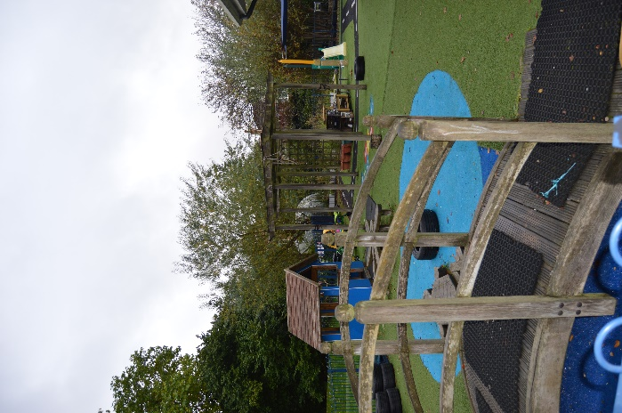
At Nevill Road Infant School, we believe that all children and young people have a fundamental right to be safeguarded and protected from neglect, harm or abuse, and that their welfare is of paramount importance.
All staff and volunteers at our school are fully trained and have a duty to ensure that all children are safe and protected from harm. If there are any concerns we will all follow the agreed procedures and protocols.
We aim to work in collaboration with everyone necessary to ensure the ultimate benefit to all of our children. The protection of children and young people is a shared community responsibility and one that is taken very seriously.
School day

In Little Brown Bears the school day runs from 9:00 to 3:00
In Nursery the school day runs from 9:00 to 3:00
In Reception the school day runs from 8:45 to 3:15
In Key Stage 1 the school day runs from 8:45 to 3:15.

There is a morning break of 20 minutes and an hour for lunch.

School Uniform

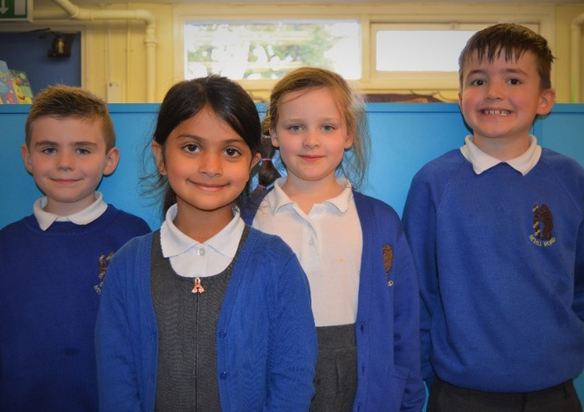
Our children wear a school uniform that helps them to identify with their school and wear clothes that are suitable for a busy day at school. Parents support our uniform policy.
All of our children wear black or grey trousers or skirt, a white polo shirt and a blue fleece, cardigan or jumper.
The school PE kit is a pair of plain black shorts, a plain white t-shirt and trainers or plimsolls, plain grey or black tracksuit bottoms are permitted.
Good quality second hand uniform is available throughout the year through the Friends of Nevill Road Schools.
Due to rising costs in school uniforms, we do not expect any of the children to have any clothes or equipment with the school logo on.
Results
Early Years 2021/2022
79% working at the expected standard or above (this is above Stockport and National results)
Phonics Screening
Year 1 80.5% working at the expected standard (this is above Stockport and National results)
Key Stage 1 2021/2022
Reading – 75.3% working at the expected standard or above (this is above Stockport and National results)
Writing – 69.1% working at the expected standard or above (this is above Stockport and National results)
Maths – 80% working at the expected standard or above (this is above Stockport and National results)
Our Governors

The Governing Body is a group of volunteers that come from every section of the community. Nevill Road Infant School's governing body is made up of staff, parents, local authority and community representatives.
Their main role is to help the school provide the best possible education for your children. To do this, they support and encourage all aspects of school life by acting as a "critical friend".
The Governing Body fully supports the school leadership team but also asks important and difficult questions. They are an integral part of life at the school. Alongside us, they celebrate the school's many successes and achievements but also alongside the school do not shy from identifying and addressing any weaknesses.
If you have any questions about the role of school governors or how to become one, do not hesitate to ask. Contact our Clerk to the Governors via the school office.
Friends of Nevill Road Schools
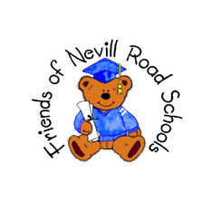
The Friends is a friendly group working to raise funds to make the school experience better for all. Every parent, carer and teacher at Nevill Road Infant School is automatically part of the group. We also welcome other ‘friends’ of the school to be part of the organisation.
The fundraising provides excellent additional equipment and resources for pupils, as well as making some school trips cheaper for parents by covering coach costs. We run a range of fundraising activities throughout the year and are always keen to hear new ideas.

What Ofsted say about us …

‘Pupils, are greeted by staff at the beginning of each day with a warm and friendly smile.’

‘…the school is a calm and happy place for pupils to learn.’

‘Pupils genuinely care about each other and they form trusting friendships across different year groups.’

‘Children in the early years and two-year-old provision, with happy, smiling faces clearly enjoying their learning.’

‘Relationships between staff and pupils are respectful.’

‘Pupils access a wide range of experiences to broaden their awareness of the world around them.’

‘Parents and carers are delighted with many aspects of the school’s work and would happily recommend it to others.’

‘Pupils are keen to learn. In classrooms, pupils have many opportunities to work together, sharing their thoughts and ideas.’

‘As soon as children enter the two-year-old provision, they are introduced to the joys of listening to stories, reciting poems and rhymes. Conversation flows freely as children learn and play.’

What our parents say about us …

‘… we all really appreciate your hard work.’

‘I am so glad we chose Nevill Road!’

‘I have nothing but praise for all of the teachers and am truly grateful for everything you do.’

‘… it’s clear how much the education of the children means to you all.’

